**High Wattage LED Bulbs**

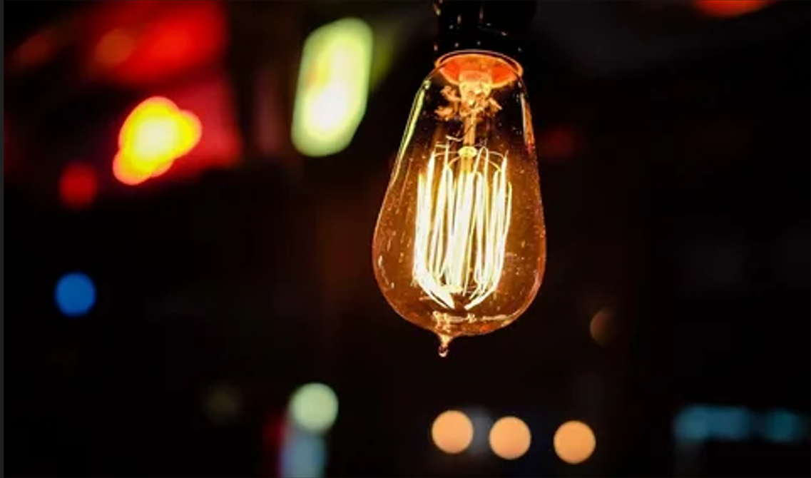

#### ****Description:****

**High Wattage LED Bulbs** are powerful, energy-efficient lighting solutions designed to replace traditional high-wattage incandescent or halogen bulbs. These bulbs provide bright, high-intensity light, making them ideal for large spaces, commercial settings, and outdoor areas. With advanced LED technology, High Wattage LED Bulbs offer long-lasting performance and significant energy savings.

* **Technology:** LED.
* **Compatibility:** Standard E26/E27 base (fits most fixtures).
* **Bulb Type:** A21 (large bulb shape), PAR38 (floodlight shape).
* **Wattage:** 20W (equivalent to 150W incandescent), 30W (equivalent to 250W incandescent).
* **Lumens:** 2500 lumens (20W), 4000 lumens (30W).
* **Color Temperature:** 2700K (warm white), 3000K (soft white), 5000K (daylight).
* **Dimmable:** Yes (select models).
* **Lifespan:** 25,000 hours.
* **Energy Efficiency:** Energy Star certified.
* **Beam Angle:** 120 degrees (A21), 40 degrees (PAR38).

#### ****Key Features:****

* **High Brightness:** Provides intense light output for large spaces and outdoor areas.
* **Energy-Efficient:** Uses up to 85% less energy than traditional high-wattage bulbs.
* **Long Lifespan:** Lasts up to 25,000 hours, reducing the need for frequent replacements.
* **Dimmable Options:** Available in dimmable models for adjustable brightness.
* **Versatile Use:** Suitable for warehouses, garages, parking lots, and outdoor floodlights.
* **Durable Design:** Built to withstand harsh environments and temperature fluctuations.

#### ****Pricing:****

* **Single Bulb (20W, A21):** $19.99
* **Single Bulb (30W, PAR38):** $29.99
* **4-Pack (20W, A21):** 69.99(69.99(17.50 per bulb)
* **4-Pack (30W, PAR38):** 109.99(109.99(27.50 per bulb)

#### ****Where to Use:****

* **Warehouses:** Provide bright, uniform lighting for large spaces.
* **Garages:** Enhance visibility for work and storage areas.
* **Parking Lots:** Ensure safety and security with high-intensity lighting.
* **Outdoor Floodlights:** Illuminate driveways, yards, and outdoor events.
* **Commercial Spaces:** Brighten up retail stores, gyms, and offices.

### ****Customer Reviews:****

* ⭐⭐⭐⭐⭐ "These High Wattage LED Bulbs are amazing! They provide incredibly bright light, and the energy savings are noticeable on my electricity bill." – Sarah L.
* ⭐⭐⭐⭐ "Great value for the price. The bulbs are bright, and the light is very natural. Highly recommend for anyone looking to upgrade their high-wattage lighting." – James T.
* ⭐⭐⭐⭐⭐ "I love how energy-efficient these bulbs are. The high brightness is perfect for my garage and outdoor floodlights." – Emily R.

### ****How to Order:****

1. Visit our website: [www.brightworldlighting.com](http://www.brightworldlighting.com/)
2. Select your preferred bulb type and pack size (Single or 4-Pack).
3. Add to cart and proceed to checkout.
4. Enjoy free shipping on all orders over $100!

### ****Warranty and Support:****

* **Warranty:** 2-year limited warranty covering manufacturing defects.
* **Customer Support:** Contact us at [support@brightworldlighting.com](mailto:support@brightworldlighting.com) or call +1-800-123-4567 for assistance.